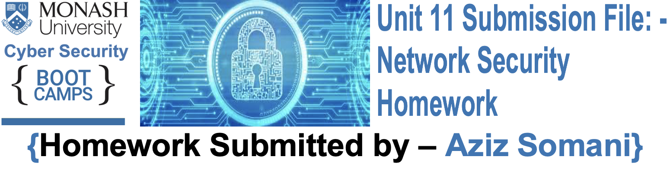

**#### Security Control Types**

The concept of defence in depth can be broken down into three different security control types. Identify the security control type of each set of defence tactics.

1. Walls, bollards, fences, guard dogs, cameras, and lighting are what type of security control?

**Answer: -** Physical Security Control. And Physical Security Control has deterrent, detective, preventive & corrective measures.

2. Security awareness programs, BYOD policies, and ethical hiring practices are what type of security control?

**Answer: -** Management (Administrative) Controls

3. Encryption, biometric fingerprint readers, firewalls, endpoint security, and intrusion detection systems are what type of security control?

**Answer: -** Technical Security Controls

--------------------------------------------------------------------------------------------------------------------------------------------------------------------------------

**#### Intrusion Detection and Attack indicator**

1. What's the difference between an IDS and an IPS?

**Answer: -** In short, an IPS can act on traffic by blocking it and preventing it from being delivered to a host-based on the contents of the packet. An IDS cannot.

IDS is designed to document and log attacks for future analysis, IDS is not designed to respond to an attack. IDS also do not alter or react to packets as they enter the network. However, an IPS do all those things that an IDS can do and as well IPS respond to attacks & block malicious traffic and prevent from being delivered to a host on the network. Also, there is a difference in how both systems connect, an IDS physically connects via a network tap (Test Access Port) or mirrored port/Switched Port Analyzer (SPAN) and an IPS physically connects in line with the flow of data that are placed in between the firewall and network switch.



2. What's the difference between an Indicator of Attack and an Indicator of Compromise?

**Answer: -** In short, Indicators of attacks are real time indicators, indicators of compromise are not.

**Indicators of attack** indicate attacks happening in real time and indicate that an attack is currently in progress but a full breach has not been determined or has not occurred yet. However, respond proactively to these intrusion attempts. The Focus on revealing the intent and end goal of the attacker regardless of the exploit or malware used in the attack.

**Indicators of compromise** (IOC) indicate previous malicious activity, that’s mean an attack has already occurred, resulting in a breach. IOCs are used to both establish an adversary's techniques, tactics, and procedures (TTPs) and expose all of the vulnerabilities used in an attack, giving network defenders the opportunity to revamp their defense as part of their mitigation strategy, and learn from an attack so it won't happen again.

--------------------------------------------------------------------------------------------------------------------------------------------------------------------------------

**#### The Cyber Kill Chain**

Name each of the seven stages for the Cyber Kill chain and provide a brief example of each.

**Answer: -** 1. **Reconnaissance**: In this step, the attacker choose the target, then attacker conduct an in-depth research on the target to identify vulnerabilities that can be exploited.

2. **Weaponization**: In this step, the attacker creates a malware weapon like a worm, virus any such in order to exploit the vulnerabilities of the target, depending on the target and the purpose of the attacker, the malware can exploit new or undetected vulnerabilities (can be as zero-day exploits) or it can focus on a combination of different vulnerabilities.

3. **Delivery**: In this step involves transmitting the weapon to the target. The attacker can employ different methods like instant message, USB drives, e-mail attachments and websites for this purpose.



4. **Exploitation**: In this step, the malware starts the action. The program code of the malware is triggered to exploit the target’s vulnerability/vulnerabilities and gaining access & compromising the user's machine.

5. **Installation**: In this step, the malware installs an access point for the attacker. This access point is also known as the backdoor and add more malicious code to granting own user root access.

6. **Command and Control**: In this step, the malware gives the attacker access in the network or system.

7. **Actions on Objective**: In this step, once the attacker gains persistent access, the attacker finally take action to fulfil the purpose, such as encryption for ransom, data exfiltration or even data destruction and accomplishing the final goal on the network or system.

--------------------------------------------------------------------------------------------------------------------------------------------------------------------------------

**#### Snort Rule Analysis**

Use the Snort rule to answer the following questions: **Snort Rule #1**

```bash

alert tcp $EXTERNAL_NET any -> $HOME_NET 5800:5820 (msg:"ET SCAN Potential VNC Scan 5800-5820"; flags:S,12; threshold: type both, track by_src, count 5, seconds 60; reference:url,doc.emergingthreats.net/2002910; classtype:attempted-recon; sid:2002910; rev:5; metadata:created_at 2010_07_30, updated_at 2010_07_30;)

```

1. Break down the Sort Rule header and explain what is happening.

**Answer: -** This means Alert user of any inbound TCP traffic port 5800:5820 for example a remote host using any port were attempted to scan the local host($HOME_NET) on ports ranging from 5800 to 5820 using TCP/IP protocol, and it is like port mapping with tool such as nmap & Metasploit.

2. What stage of the Cyber Kill Chain does this alert violate?

**Answer: -** Reconnaissance.

3. What kind of attack is indicated?

**Answer: -** This attack is indicating that threat was founds with port mapping, and it is doing potential VNC scan.



**Snort Rule #2**

```bash

alert tcp $EXTERNAL_NET $HTTP_PORTS -> $HOME_NET any (msg:"ET POLICY PE EXE or DLL Windows file download HTTP"; flow:established,to_client; flowbits:isnotset,ET.http.binary; flowbits:isnotset,ET.INFO.WindowsUpdate; file_data; content:"MZ"; within:2; byte_jump:4,58,relative,little; content:"PE|00 00|"; distance:-64; within:4; flowbits:set,ET.http.binary; metadata: former_category POLICY; reference:url,doc.emergingthreats.net/bin/view/Main/2018959; classtype:policy-violation; sid:2018959; rev:4; metadata:created_at 2014_08_19, updated_at 2017_02_01;)

```

1. Break down the Sort Rule header and explain what is happening.

**Answer: -** This means the remote host through http ports try to download DLL windows file and attempted to deliver a malicious payload to any port of the machine.

2. What layer of the Defense in Depth model does this alert violate?

**Answer: -** It is showing a layer of Defense “ET POLICY PE EXE or DLL Windows file

download HTTP” that means the layer would be Policies, Procedures and Awareness (Password, policies and data classification).

3. What kind of attack is indicated?

**Answer: -** Distributed Denial of Service (DDoS) attacks.

**Snort Rule #3**

- Your turn! Write a Snort rule that alerts when traffic is detected inbound on port 4444 to the local network on any port. Be sure to include the `msg` in the Rule Option.

**Answer: -**

Sample Snort Rule: -

alert tcp any any -> any 4444 (msg: "Testing Alert" ; sid:1000001; rev:1; )

Example Snort Rule: -

alert tcp $EXTERNAL_NET 4444 -> $HOME_NET any (msg: "ET Possible Trojan or malware-backdoor)

--------------------------------------------------------------------------------------------------------------------------------------------------------------------------------



**### Part 2: "Drop Zone" Lab (#### Log into the Azure `firewalld` machine)**

**#### Uninstall `ufw`**

- Run the command that removes any running instance of `ufw`.

**Answer: -** ```bash

$ <sudo ufw disable>

```

--------------------------------------------------------------------------------------------------------------------------------------------------------------------------------

**#### Enable and start `firewalld`**

By default, these service should be running. If not, then run the following commands:

- Run the commands that enable and start `firewalld` upon boots ansud d reboots.

**Answer: -** ```bash

$ < sudo systemctl enable firewalld>

$ < sudo systemctl start firewalld >

```

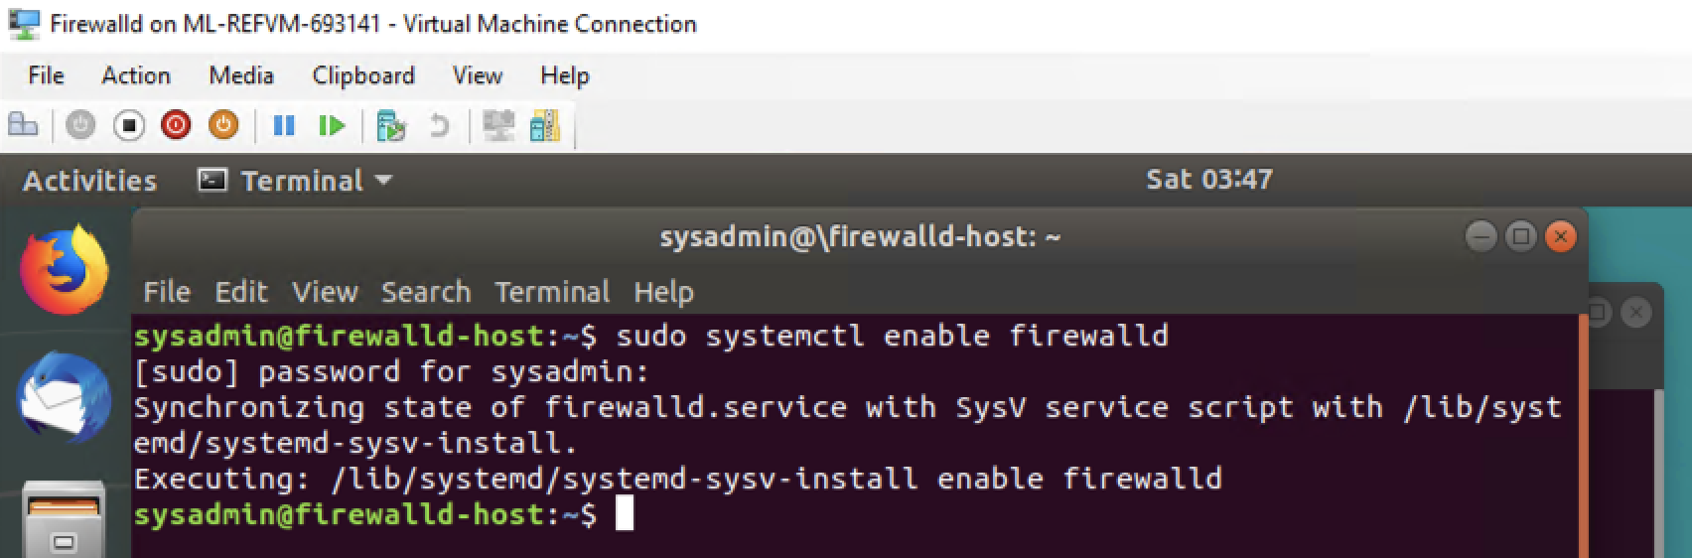

Note: This will ensure that `firewalld` remains active after each reboot.



**#### Confirm that the service is running.**

- Run the command that checks whether or not the `firewalld` service is up and running.

```bash

$ < sudo systemctl status firewalld .service >

```

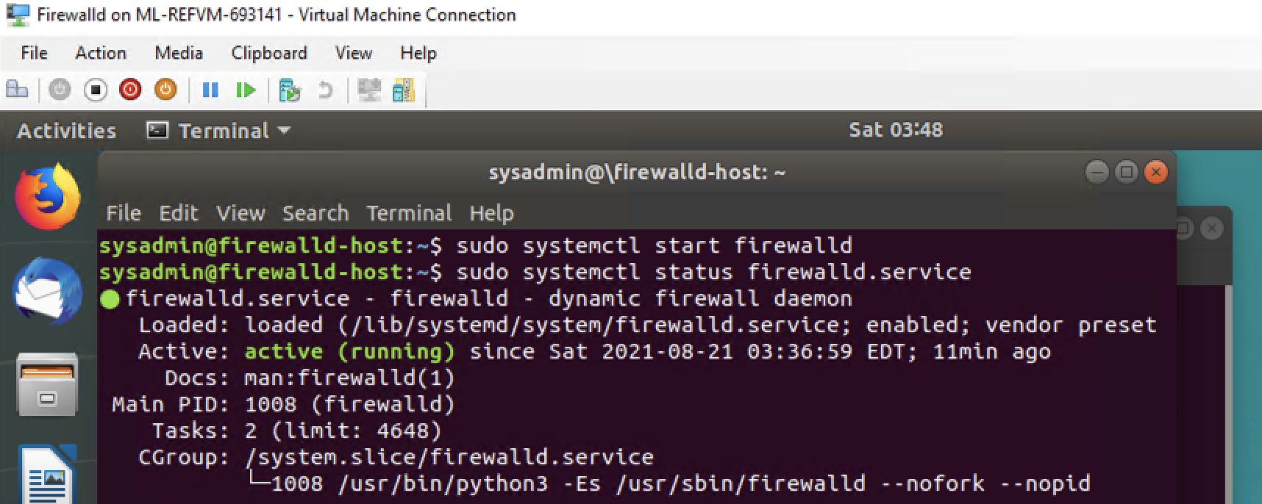

**#### List all firewall rules currently configured.**

Next, lists all currently configured firewall rules. This will give you a good idea of what's currently configured and save you time in the long run by not doing double work.

- Run the command that lists all currently configured firewall rules:

```bash

$ <sudo firewall-cmd --list-all>

```

- Take note of what Zones and settings are configured. You many need to remove unneeded services and settings.

**#### List all supported service types that can be enabled.**

- Run the command that lists all currently supported services to see if the service you need is available

```bash

$ <sudo firewall-cmd --get-services>

```

- We can see that the `Home` and `Drop` Zones are created by default.



**#### Zone Views**

- Run the command that lists all currently configured zones.

```bash

$ <sudo firewall-cmd --get-zones>

```

- We can see that the `Public` and `Drop` Zones are created by default. Therefore, we will need to create Zones for `Web`, `Sales`, and `Mail`.

**#### Create Zones for `Web`, `Sales` and `Mail`.**

- Run the commands that creates Web, Sales and Mail zones.

```bash

$ <sudo firewall-cmd --permanent --new-zone=web>

$ <sudo firewall-cmd --permanent --new-zone=mail>

$ <sudo firewall-cmd --permanent --new-zone=sales>

```

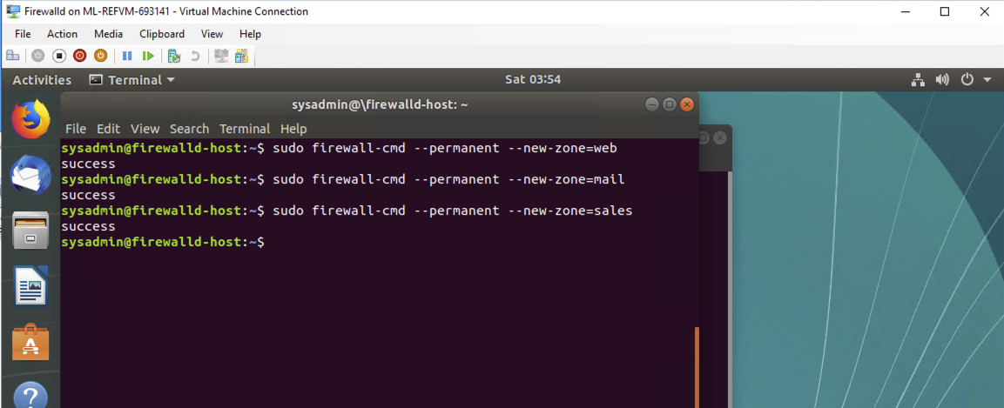



**#### Set the zones to their designated interfaces:**

- Run the commands that sets your `eth` interfaces to your zones.

```bash

$ <sudo firewall-cmd --zone=public --change-interface=eth0>

$ <sudo firewall-cmd --zone=web --change-interface=eth1>

$ <sudo firewall-cmd --zone=sales --change-interface=eth2>

$ <sudo firewall-cmd --zone=mail --change-interface=eth3>

```

**#### Add services to the active zones:**

- Run the commands that add services to the **public** zone, the **web** zone, the **sales** zone, and the **mail** zone.

- Public:

```bash

$ <sudo firewall-cmd --zone=public --add-service=smtp>

$ <sudo firewall-cmd --zone=public --add-service=http>

$ <sudo firewall-cmd --zone=public --add-service=https>

$ <sudo firewall-cmd --zone=public --add-service=pop3>

```

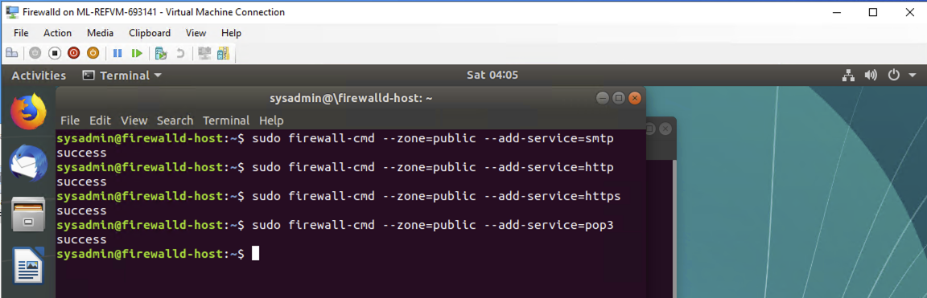

- Web:

```bash

$ <sudo firewall-cmd --zone=web --add-service=http --permanet>

```

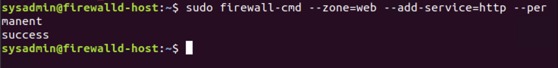



- Sales

```bash

$ <sudo firewall-cmd --zone=sales --add-service=https>n```

- Mail

```bash

$ <sudo firewall-cmd --zone=mail --add-service=smtp>

$ <sudo firewall-cmd --zone=mail --add-service=pop3> ```

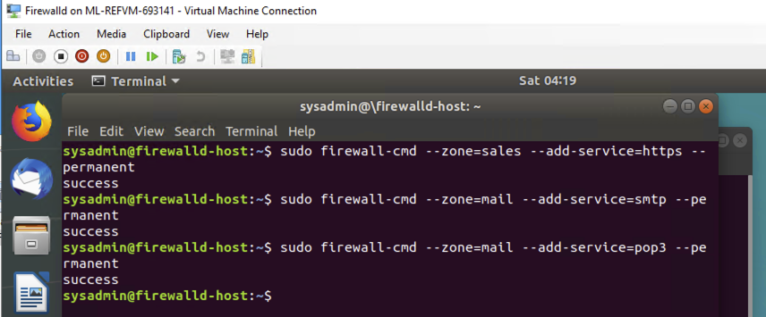

- What is the status of `http`, `https`, `smtp` and `pop3`?

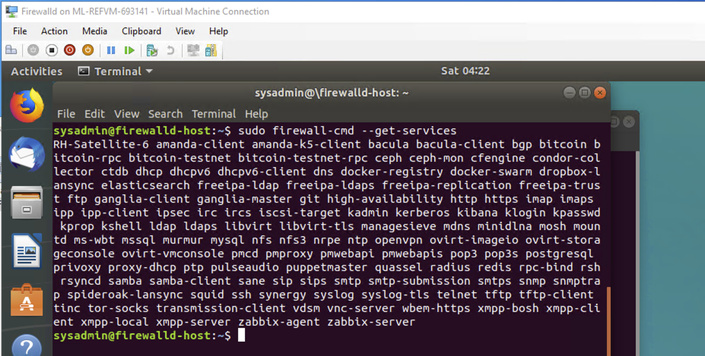



**#### Add your adversaries to the Drop Zone.**

- Run the command that will add all current and any future blacklisted IPs to the Drop Zone.

**Answer: -**

```bash

$ <sudo firewall-cmd --permanent --zone=drop --add-source=10.208.56.23>

$ <sudo firewall-cmd --permanent --zone=drop --add-source=135.95.103.76>

$ <sudo firewall-cmd --permanent --zone=drop --add-source=76.34.169.118>

```

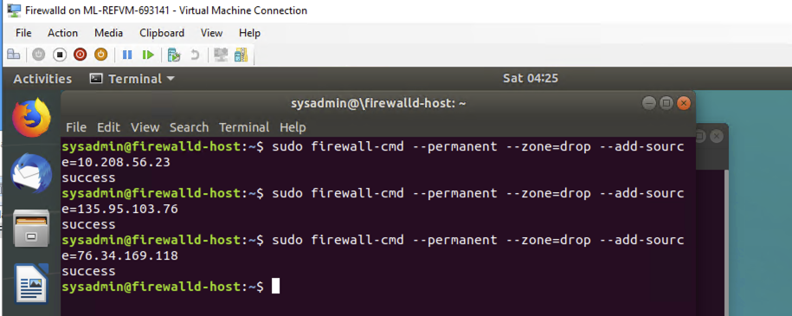

**#### Make rules permanent then reload them:**

It's good practice to ensure that your `firewalld` installation remains nailed up and retains its services across reboots. This ensure that the network remains secured after unplanned outages such as power failures.

- Run the command that reloads the `firewalld` configurations and writes it to memory

```bash

$ <sudo firewall-cmd--reload>

```

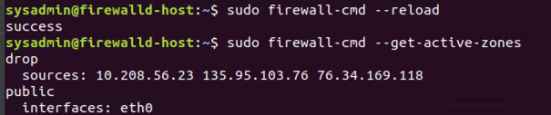



**#### View active Zones**

Now, we'll want to provide truncated listings of all currently **active** zones. This a good time to verify your zone settings.

- Run the command that displays all zone services.

```bash

$ <sudo firewall-cmd --get-active-zones>

```

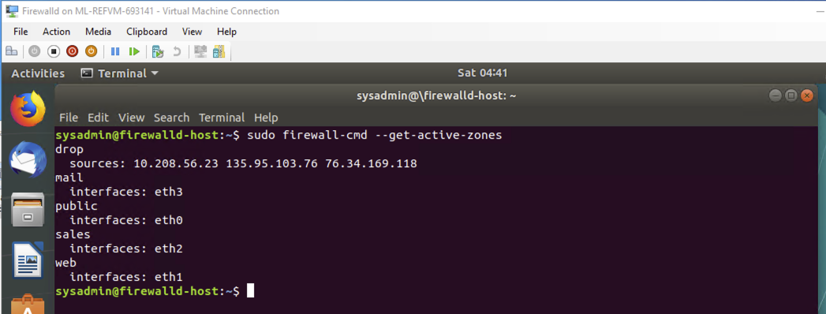

**#### Block an IP address**

- Use a rich-rule that blocks the IP address `138.138.0.3`.

```bash

$ <sudo firewall-cmd --zone=public --add-rich-rule='rule family="ipv4" source address="138.138.0.3" reject'>

```

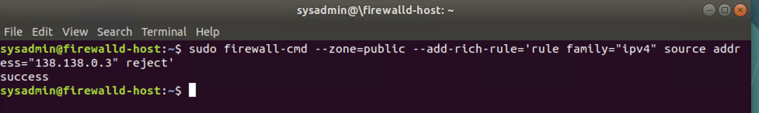



**#### Block Ping/ICMP Requests**

Harden your network against `ping` scans by blocking `icmp ehco` replies.

- Run the command that blocks `pings` and `icmp` requests in your `public` zone.

```bash

$ <sudo firewall-cmd --zone=public --add-icmp-block=echo-reply --add-icmp-block=echo-request>

```

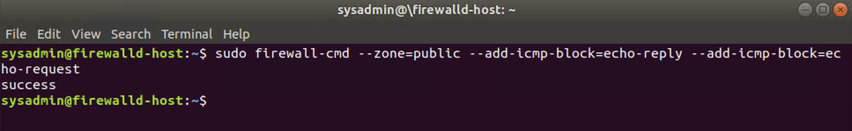

**#### Rule Check**

Now that you've set up your brand new `firewalld` installation, it's time to verify that all of the settings have taken effect.

- Run the command that lists all of the rule settings. Do one command at a time for each zone.

```bash

$ <sudo firewall-cmd --zone=public --list-all>

$ <sudo firewall-cmd --zone=sales --list-all>

$ <sudo firewall-cmd --zone=mail --list-all>

$ <sudo firewall-cmd --zone=web --list-all>

$ <sudo firewall-cmd --permanent --zone=drop --list-all>

```

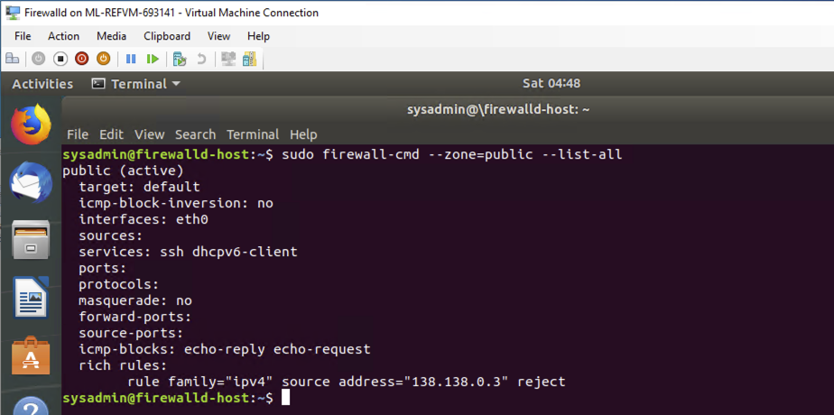

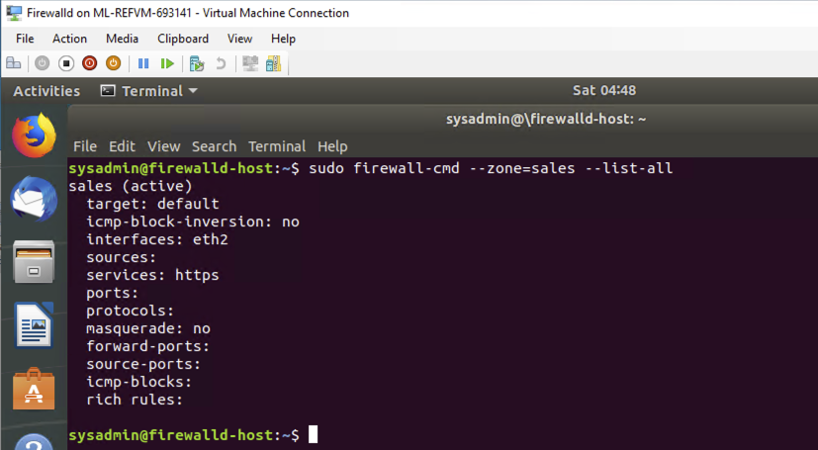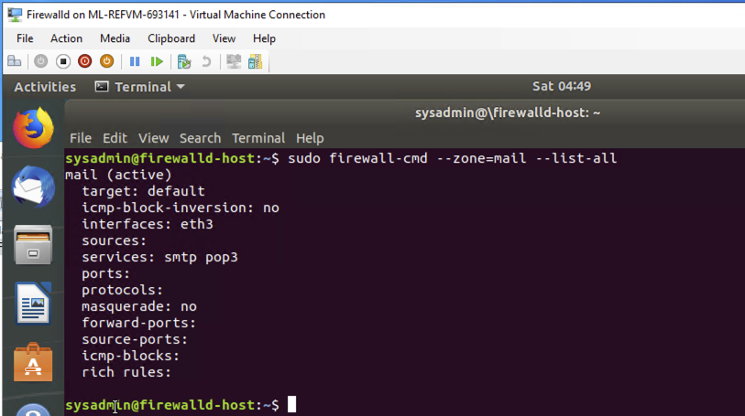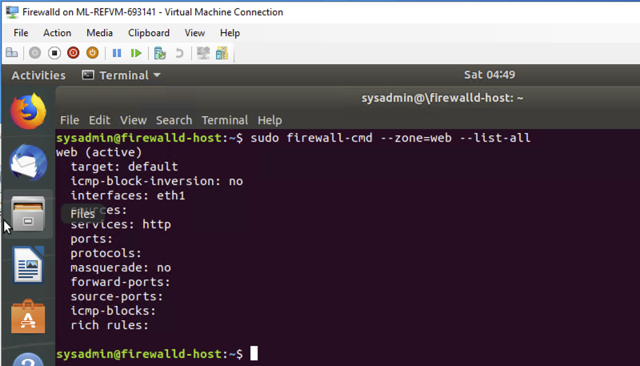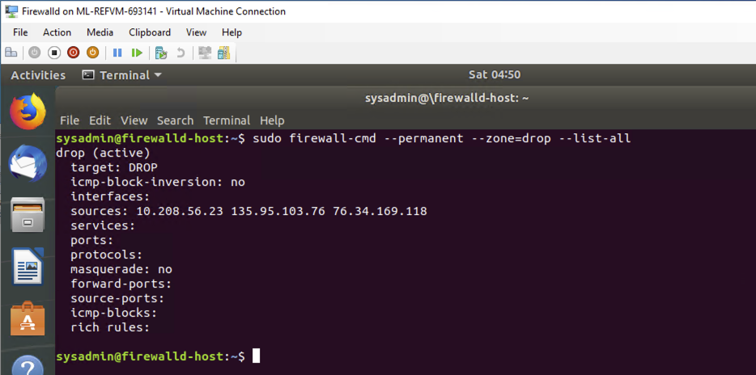

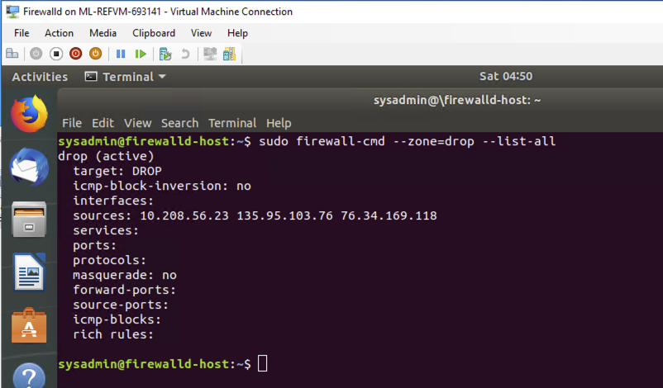

- Are all of our rules in place? If not, then go back and make the necessary modifications before checking again.

**Congratulations! You have successfully configured and deployed a fully comprehensive `firewalld` installation.**

------------------------------------------------------------------------------------------------------------------------

**### Part 3: IDS, IPS, DiD and Firewalls**

Now, we will work on another lab. Before you start, complete the following review questions.

**#### IDS vs. IPS Systems**

1. Name and define two ways an IDS connects to a network.

**Answer 1:** Network intrusion detection system (NIDS) filters an entire subnet on a network.

* Matches all traffic to a known library of attack signatures.
* Passively examines network traffic at the points it is deployed.
* Relatively easy to deploy and difficult to detect by attackers.

**Answer 2:** Host-based intrusion detection system (HIDS) runs locally on a host-based system or user’s workstation or server.

* Acts as a second line of defense against malicious traffic that successfully bypasses a NIDS.
* Examines entire file systems on a host, compares them to previous snapshots or a baseline, and generates an alert if there are significant differences between the two.



2. Describe how an IPS connects to a network.

**Answer: -** IPS physically connects inline with the flow of data. An IPS is typically placed in between the firewall and network switch, IPS requires more robust hardware due to the amount of traffic flowing through it and automatically takes action by blocking and logging a threat, thus not requiring administrative intervention.

3. What type of IDS compares patterns of traffic to predefined signatures and is unable to detect Zero-Day attacks?

**Answer: -** Signature-based.

4. Which type of IDS is beneficial for detecting all suspicious traffic that deviates from the well-known baseline and is excellent at detecting when an attacker probes or sweeps a network?

**Answer: -** Anomaly-based.

**#### Defense in Depth**

1. For each of the following scenarios, provide the layer of Defense in Depth that applies:

1. A criminal hacker tailgates an employee through an exterior door into a secured facility, explaining that they forgot their badge at home.

**Answer: -** Physical Layer.

2. A zero-day goes undetected by antivirus software.

**Answer: -** Application Layer & Host Layer.

3. A criminal successfully gains access to HR’s database.

**Answer: -** Data Layer.

4. A criminal hacker exploits a vulnerability within an operating system.

**Answer: -** Host Layer.

5. A hacktivist organization successfully performs a DDoS attack, taking down a government website.

**Answer: -** Network Layer.



6. Data is classified at the wrong classification level.

**Answer: -** Policies Procedures and Awareness Layer.

7. A state sponsored hacker group successfully firewalked an organization to produce a list of active services on an email server.

**Answer: -** Perimeter Layer.

------------------------------------------------------------------------------------------------------------------------

2. Name one method of protecting data-at-rest from being readable on hard drive.

**Answer: -** Data Encryption or Advanced Encryption Standard.

3. Name one method to protect data-in-transit.

**Answer: -** Encrypted Connections (HTTPS, SSL, TLS, FTPS) and Symmetric Encryption with a set Session Key.

4. What technology could provide law enforcement with the ability to track and recover a stolen laptop.

**Answer: -** IMEI number, route tracing and GPS or Wi-Fi geolocation using LoJack.

5. How could you prevent an attacker from booting a stolen laptop using an external hard drive?

**Answer: -** Hard disk encryption using a strong algorithm and mandatory BIOS or UEFI password policy for laptop.

**#### Firewall Architectures and Methodologies**

1. Which type of firewall verifies the three-way TCP handshake? TCP handshake checks are designed to ensure that session packets are from legitimate sources.

**Answer: -** Circuit-level gateways work by verifying the three-way TCP handshake.

2. Which type of firewall considers the connection as a whole? Meaning, instead of looking at only individual packets, these firewalls look at whole streams of packets at one time.

**Answer: -** Stateful Firewall, these firewalls work by monitoring the whole TCP connection, instead of just its constituent packets



3. Which type of firewall intercepts all traffic prior to being forwarded to its final destination. In a sense, these firewalls act on behalf of the recipient by ensuring the traffic is safe prior to forwarding it?

**Answer: -** Proxy firewalls intercept all traffic on its way to its final destination, without the data source knowing. A connection is established to the proxy firewall, which inspects the traffic and forwards it if it's determined to be safe, or drops it if it's determined to be malicious

4. Which type of firewall examines data within a packet as it progresses through a network interface by examining source and destination IP address, port number, and packet type- all without opening the packet to inspect its contents?

**Answer: -** Packet-filtering firewalls and it’s the oldest type of firewall architecture, It creates checkpoints within a router or switch and examines packet data as it is transported through a network interface.

5. Which type of firewall filters based solely on source and destination MAC address?

**Answer: -** MAC Layer Filtering Firewall, MAC layer firewalls, also referred to as MAC filtering, are commonly found on Wi-Fi systems, this firewall will first compare a device's MAC address against a statically approved list of MAC addresses. If there is a match, all traffic will be forwarded, one advantage of MAC layer firewalls is that they may help secure a network from novice attackers, One disadvantage is that this security control can easily be bypassed by MAC spoofing, the process of changing a MAC address to match that of another, typically one that is already allowed in the firewall.



**### Bonus Lab: "Green Eggs & SPAM"**

In this activity, you will target spam, uncover its whereabouts, and attempt to discover the intent of the attacker.

- You will assume the role of a Jr. Security administrator working for the Department of Technology for the State of California.

- As a junior administrator, your primary role is to perform the initial triage of alert data: the initial investigation and analysis followed by an escalation of high priority alerts to senior incident handlers for further review.

- You will work as part of a Computer and Incident Response Team (CIRT), responsible for compiling **Threat Intelligence** as part of your incident report.

**#### Threat Intelligence Card**

**Note**: Log into the Security Onion VM and use the following **Indicator of Attack** to complete this portion of the homework.

Locate the following Indicator of Attack in Sguil based off of the following:

- **Source IP/Port**: `188.124.9.56:80`

- **Destination Address/Port**: `192.168.3.35:1035`

- **Event Message**: `ET TROJAN JS/Nemucod.M.gen downloading EXE payload`

Answer the following:

1. What was the indicator of an attack?

- Hint: What do the details of the reveal?

**Answer: -** Red alert in Sguil analyst console, leading to the discovery of a “GET /40.exe HTTP/1.1” request with a server response of “HTTP/1.1 200 OK” for an unauthorized file download.

2. What was the adversarial motivation (purpose of attack)?

**Answer: -** Mostly to steal private and sensitive data and after that target to the financial sector and employee information details to steal money.



3. Describe observations and indicators that may be related to the perpetrators of the intrusion. Categorize your insights according to the appropriate stage of the cyber kill chain, as structured in the following table.

| TTP | Example | Findings |

| **Reconnaissance** | How did they attacker locate the victim? |

| **Weaponization** | What was it that was downloaded?|

| **Delivery** | How was it downloaded?|

| **Exploitation** | What does the exploit do?|

| **Installation** | How is the exploit installed?|

| **Command & Control (C2)** | How does the attacker gain control of the remote machine?|

| **Actions on Objectives** | What does the software that the attacker sent do to complete it's tasks?|

**Answer: -**

* **Reconnaissance** – An email addresses could be exposed through third party client or client email lists.
* **Weaponization** - JavaScript downloader called JS/Nemucod, which is attached directly to the emails inside os a ZIP file.
* **Delivery** - Unsolicited SPAM email.
* **Exploitation** - Nemucod will use three different ActiveX controls: WScript.Shell, MSXML2.XMLHTTP and ADODB.Stream to save an executable file to the temporary folder %TEMP% and to run it; right after that, Nemucod will open a legitimate PDF file in the browser: this document is used as a decoy to let the user believe they're actually viewing a real invoice, as shown below.
* **Installation** - A JavaScript file then downloads a simple EXE file which is then invoked directly in the background through the WScript.Shell ActiveX control. Right after that, the malware opens the decoy PDF document through the ADODB. This campaign also downloads a DLL library which is invoked through rundll32.exe; the entry point is still "DLLRegisterServer" and the decoy PDF document is always the same.
* **Command and Control** - Gozi starts phoning home exclusively after the first reboot.
* **Actions on Objectives** - The executable files downloaded by Nemucod are used to retrieve a Trojan-Downloader called Fareit or Pony Downloader, which in turn downloads another set of executable files containing the Gozi infostealer malware.



4. What are your recommended mitigation strategies?

**Answer: -** Enforce security awareness programs with regularity and Security awareness training with all staff to play in minimising the serious cybersecurity threats posed to end users by phishing attacks and social engineering.

5. List your third-party references.

**Answer: -**

<https://www.secureworks.com/research/gozipdf>

<https://www.certego.net/en/news/italian-spam-campaigns-using-js-nemucod-downloader/>

[https://www.virustotal.com/gui/file/6cb50ecb44007c42666958ae58d724505fdd6414fd574ea 5cc6e5cf03c640ec0/community](https://www.virustotal.com/gui/file/6cb50ecb44007c42666958ae58d724505fdd6414fd574ea%205cc6e5cf03c640ec0/community)

[https://www.virustotal.com/gui/url/e0114a871f807bff543161758dfaaffbf5cf458fd6c1fb242b a79bc3f1d1c66d/detection](https://www.virustotal.com/gui/url/e0114a871f807bff543161758dfaaffbf5cf458fd6c1fb242b%20a79bc3f1d1c66d/detection)

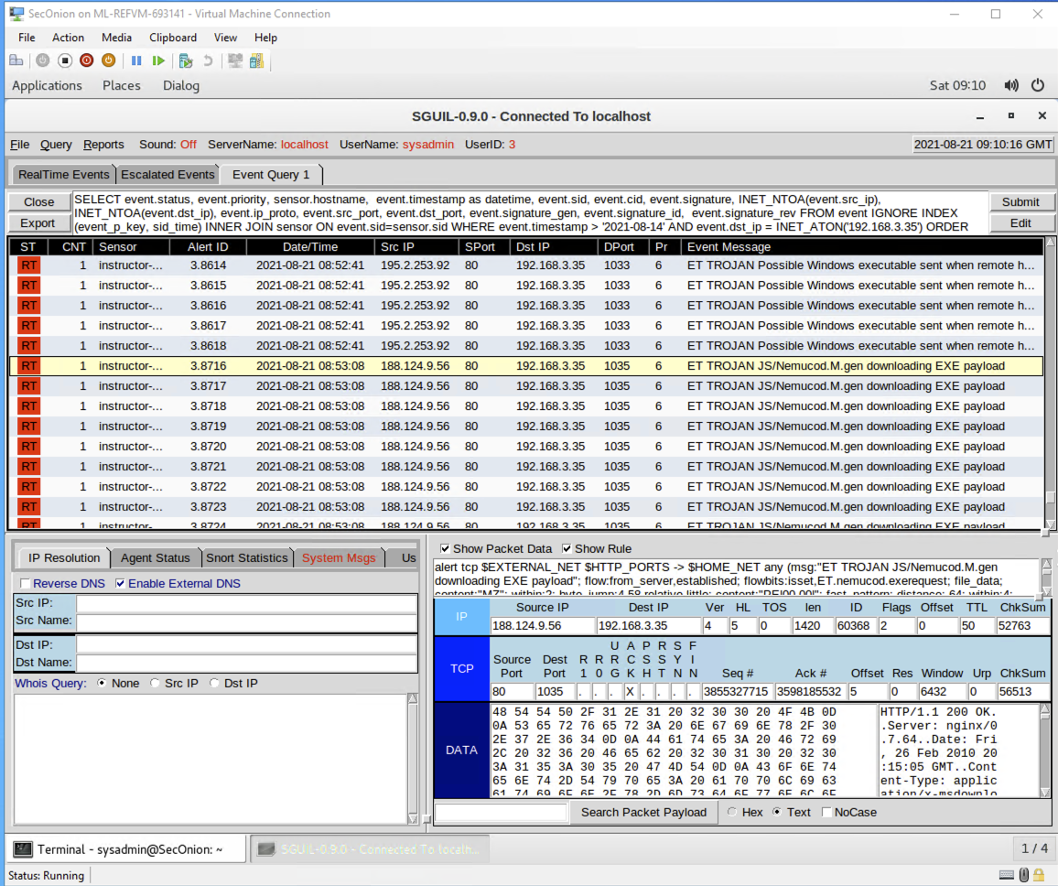

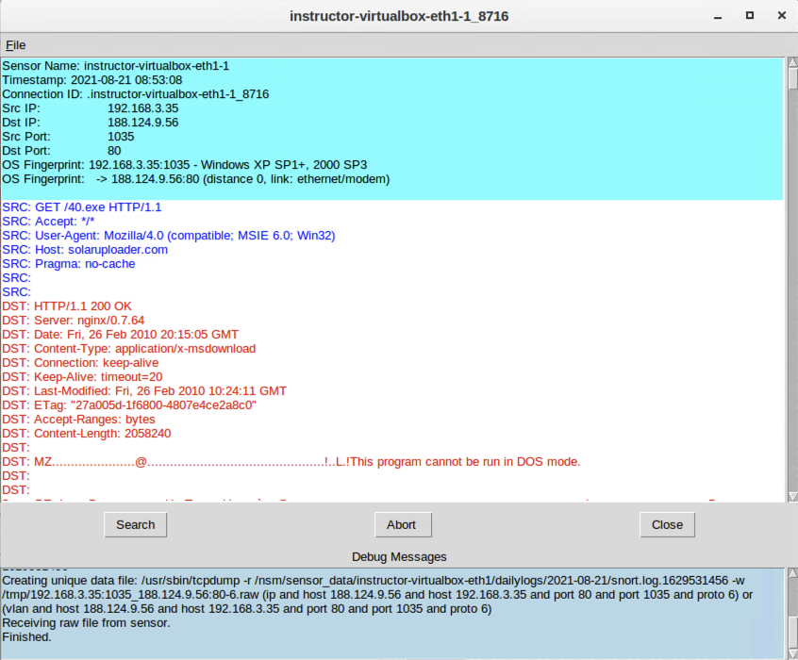

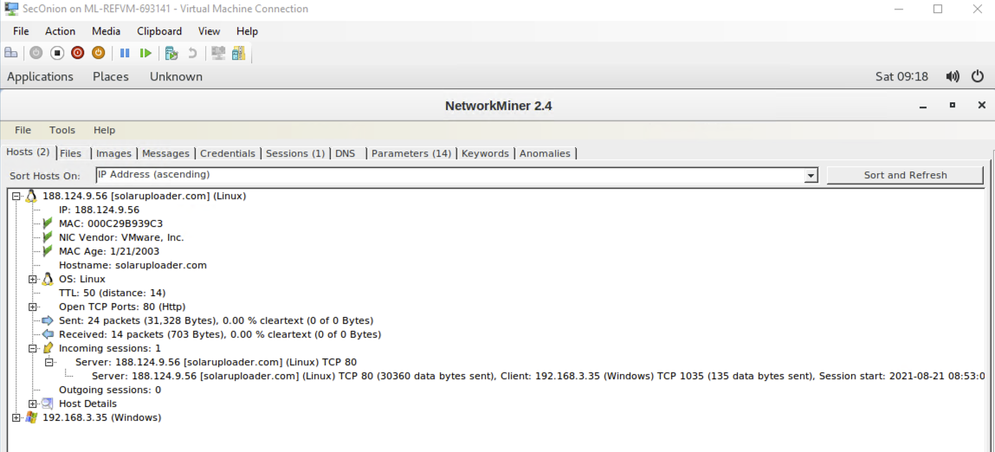

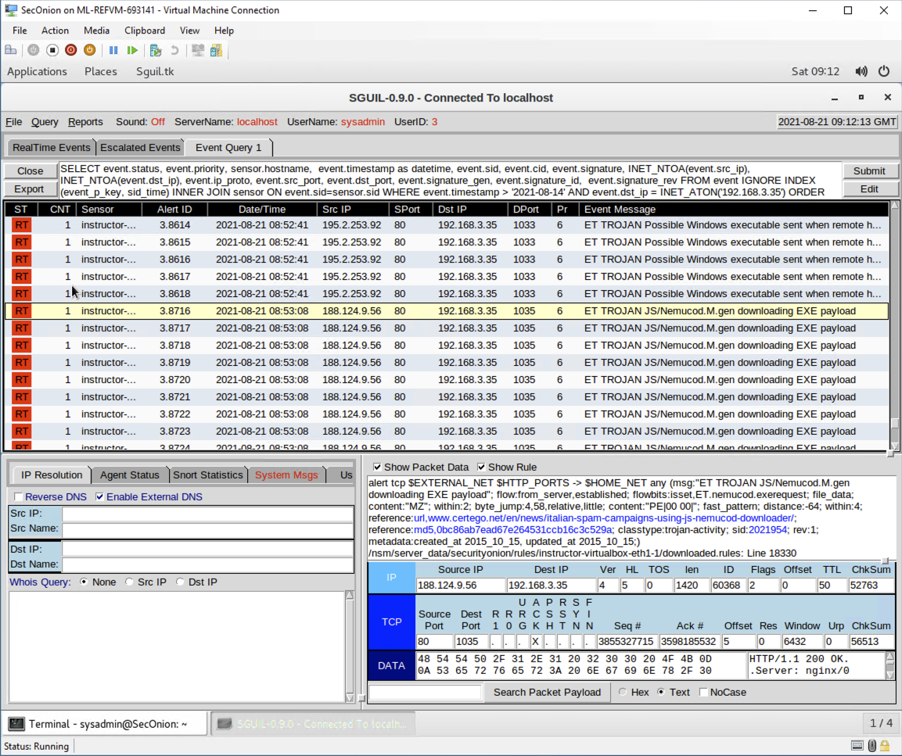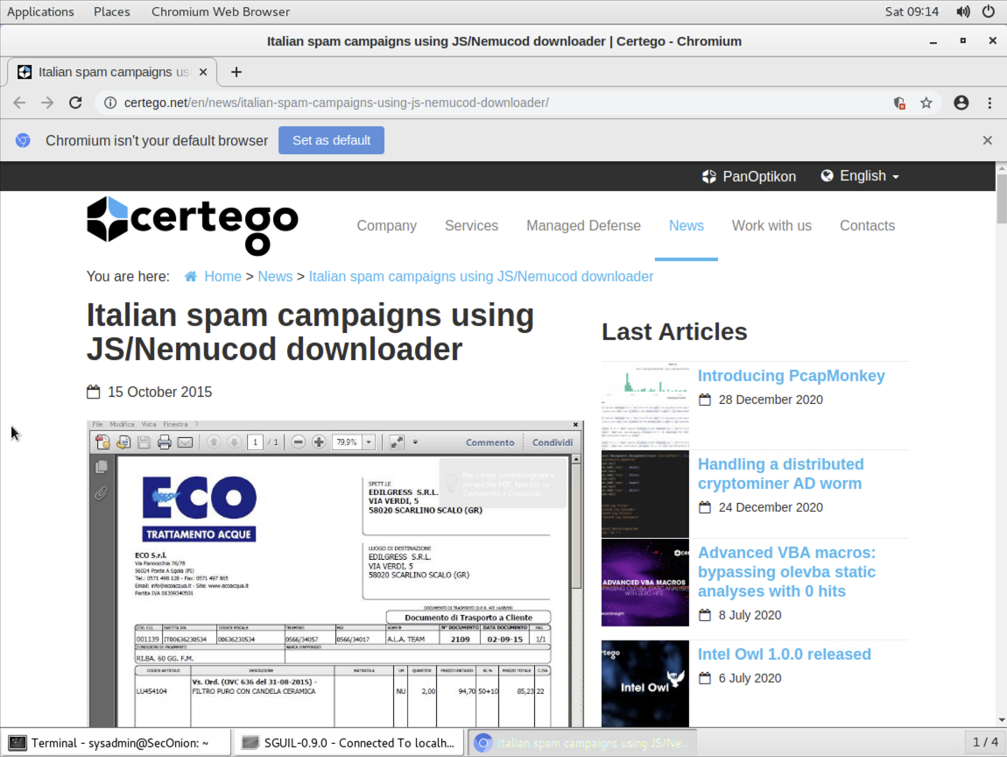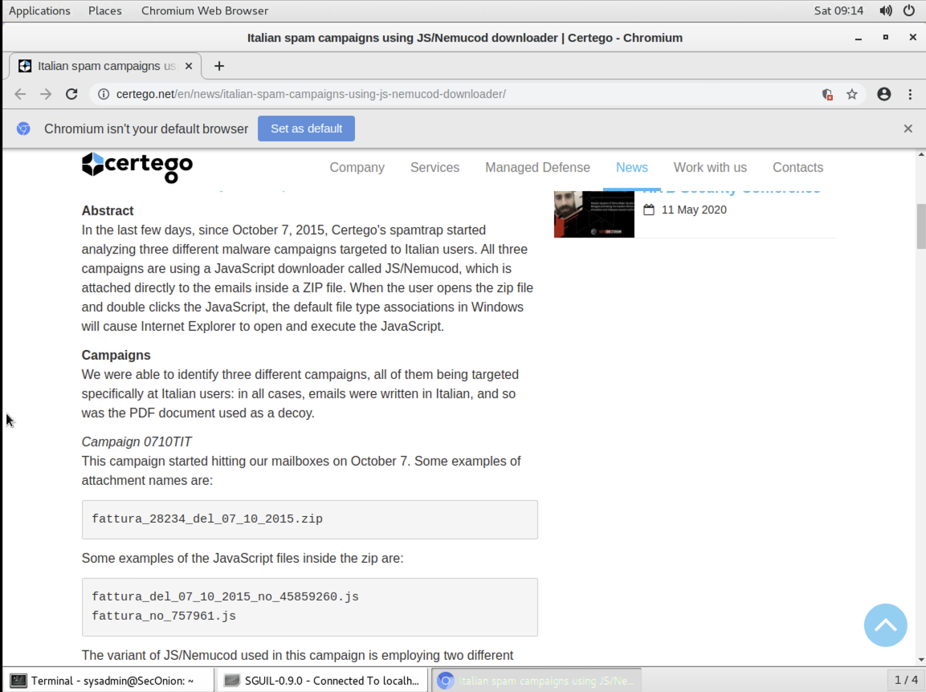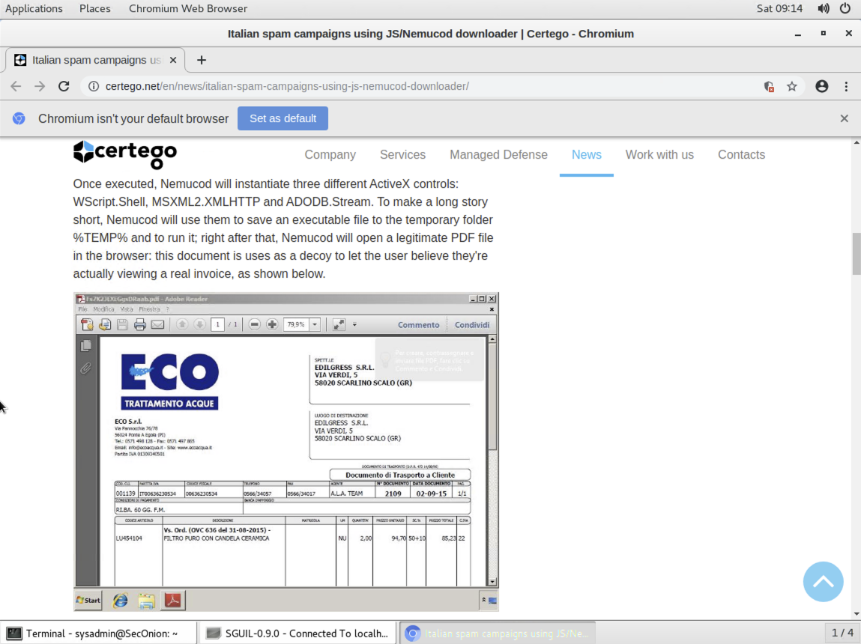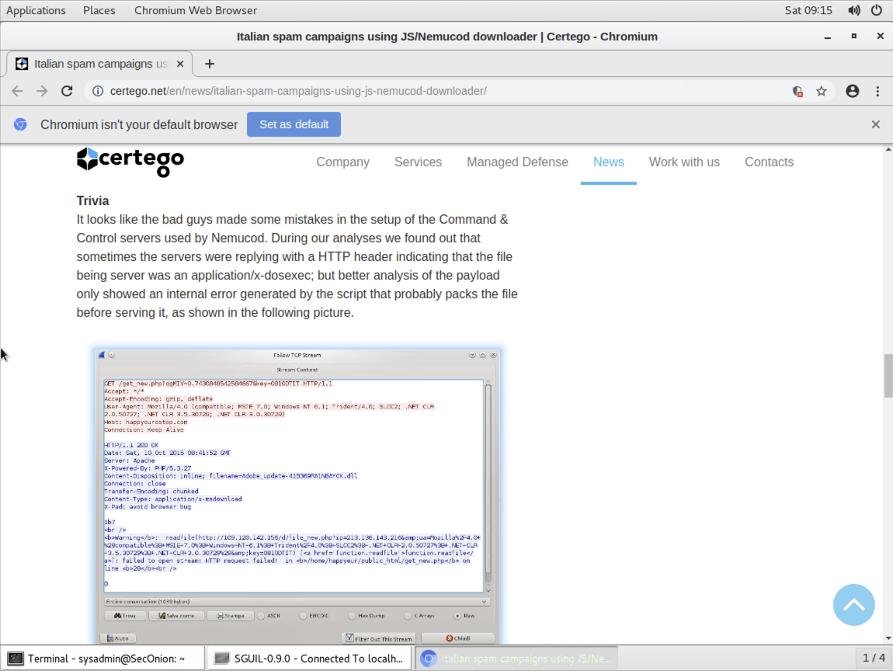

**Thank you,**

**Aziz Somani**